Introduction of DBMS (Database Management System)

A Database Management System (DBMS) is a software solution designed to efficiently manage, organize, and retrieve data in a structured manner. It serves as a critical component in modern computing, enabling organizations to store, manipulate, and secure their data effectively. From small applications to enterprise systems, DBMS plays a vital role in supporting data-driven decision-making and operational efficiency.
In this article, we will explain the key concepts, benefits, and types of Database Management Systems (DBMS). We’ll also cover how DBMS solutions work, why they’re important for modern applications, and what features they offer to ensure data integrity, security, and efficient retrieval.

What is a DBMS?
A DBMS is a system that allows users to create, modify, and query databases while ensuring data integrity, security, and efficient data access. Unlike traditional file systems, DBMS minimizes data redundancy, prevents inconsistencies, and simplifies data management with features like concurrent access and backup mechanisms. It organizes data into tables, views, schemas, and reports, providing a structured approach to data management.

Example:
A university database can store and manage student information, faculty records, and administrative data, allowing seamless retrieval, insertion, and deletion of information as required.

Key Features of DBMS
- Data Modeling: Tools to create and modify data models, defining the structure and relationships within the database.
- Data Storage and Retrieval: Efficient mechanisms for storing data and executing queries to retrieve it quickly.
- Concurrency Control: Ensures multiple users can access the database simultaneously without conflicts.
- Data Integrity and Security: Enforces rules to maintain accurate and secure data, including access controls and encryption.
- Backup and Recovery: Protects data with regular backups and enables recovery in case of system failures.

Advantages of DBMS
- Data organization: A DBMS allows for the organization and storage of data in a structured manner, making it easy to retrieve and query the data as needed.
- Data integrity: A DBMS provides mechanisms for enforcing data integrity constraints, such as constraints on the values of data and access controls that restrict who can access the data.
- Concurrent access: A DBMS provides mechanisms for controlling concurrent access to the database, to ensure that multiple users can access the data without conflicting with each other.
- Data security: A DBMS provides tools for managing the security of the data, such as controlling access to the data and encrypting sensitive data.
- Backup and recovery: A DBMS provides mechanisms for backing up and recovering the data in the event of a system failure.
- Data sharing: A DBMS allows multiple users to access and share the same data, which can be useful in a collaborative work environment.

Disadvantages of DBMS
- Complexity: DBMS can be complex to set up and maintain, requiring specialized knowledge and skills.
- Performance overhead: The use of a DBMS can add overhead to the performance of an application, especially in cases where high levels of concurrency are required.
- Scalability: The use of a DBMS can limit the scalability of an application, since it requires the use of locking and other synchronization mechanisms to ensure data consistency.
- Cost: The cost of purchasing, maintaining and upgrading a DBMS can be high, especially for large or complex systems.
- Limited Use Cases: Not all use cases are suitable for a DBMS, some solutions don’t need high reliability, consistency or security and may be better served by other types of data storage.

Applications of DBMS
- Enterprise Information: Sales, accounting, human resources, Manufacturing, online retailers.
- Banking and Finance Sector: Banks maintaining the customer details, accounts, loans, banking transactions, credit card transactions. Finance: Storing the information about sales and holdings, purchasing of financial stocks and bonds.
- University: Maintaining the information about student course enrolled information, student grades, staff roles.
- Airlines: Reservations and schedules.
- Telecommunications: Prepaid, postpaid bills maintance.

Three schema Architecture
- The three schema architecture is also called ANSI/SPARC architecture or three-level architecture.
- This framework is used to describe the structure of a specific database system.
- The three schema architecture is also used to separate the user applications and physical database.
- The three schema architecture contains three-levels. It breaks the database down into three different categories.

The three-schema architecture is as follows:
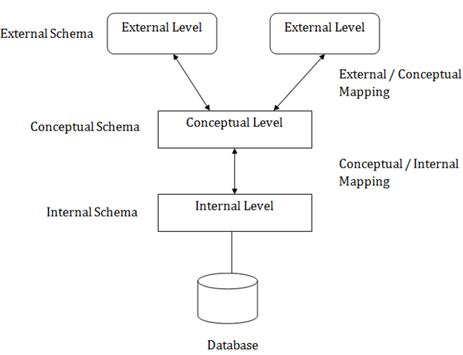
In the above diagram:
- It shows the DBMS architecture.
- Mapping is used to transform the request and response between various database levels of architecture.
- Mapping is not good for small DBMS because it takes more time.
- In External / Conceptual mapping, it is necessary to transform the request from external level to conceptual schema.
- In Conceptual / Internal mapping, DBMS transform the request from the conceptual to internal level.

Objectives of Three schema Architecture

The main objective of three level architecture is to enable multiple users to access the same data with a personalized view while storing the underlying data only once. Thus, it separates the user's view from the physical structure of the database. This separation is desirable for the following reasons:
- Different users need different views of the same data.
- The approach in which a particular user needs to see the data may change over time.
- The users of the database should not worry about the physical implementation and internal workings of the database such as data compression and encryption techniques, hashing, optimization of the internal structures etc.
- All users should be able to access the same data according to their requirements.
- DBA should be able to change the conceptual structure of the database without affecting the user's
- Internal structure of the database should be unaffected by changes to physical aspects of the storage.

1. Internal Level
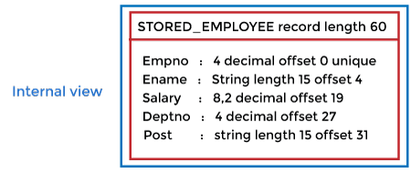
- The internal level has an internal schema which describes the physical storage structure of the database.
- The internal schema is also known as a physical schema.
- It uses the physical data model. It is used to define that how the data will be stored in a block.
- The physical level is used to describe complex low-level data structures in detail.

2. Conceptual Level
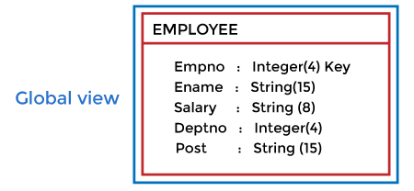
- The conceptual schema describes the design of a database at the conceptual level. Conceptual level is also known as logical level.
- The conceptual schema describes the structure of the whole database.
- The conceptual level describes what data are to be stored in the database and also describes what relationship exists among those data.
- In the conceptual level, internal details such as an implementation of the data structure are hidden.
- Programmers and database administrators work at this level.

3. External Level
- At the external level, a database contains several schemas that sometimes called as subschema. The subschema is used to describe the different view of the database.
- An external schema is also known as view schema.
- Each view schema describes the database part that a particular user group is interested and hides the remaining database from that user group.
- The view schema describes the end user interaction with database systems.

Mapping between Views
The three levels of DBMS architecture don't exist independently of each other. There must be correspondence between the three levels i.e. how they actually correspond with each other. DBMS is responsible for correspondence between the three types of schema. This correspondence is called Mapping.
There are basically two types of mapping in the database architecture:
- Conceptual/ Internal Mapping
- External / Conceptual Mapping
Conceptual/ Internal Mapping
The Conceptual/ Internal Mapping lies between the conceptual level and the internal level. Its role is to define the correspondence between the records and fields of the conceptual level and files and data structures of the internal level.
External/ Conceptual Mapping
The external/Conceptual Mapping lies between the external level and the Conceptual level. Its role is to define the correspondence between a particular external and the conceptual view.

DBMS Architecture
- The DBMS design depends upon its architecture. The basic client/server architecture is used to deal with a large number of PCs, web servers, database servers and other components that are connected with networks.
- The client/server architecture consists of many PCs and a workstation which are connected via the network.
- DBMS architecture depends upon how users are connected to the database to get their request done.

Types of DBMS Architecture
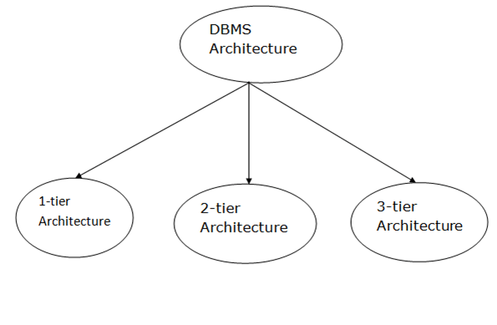
Database architecture can be seen as a single tier or multi-tier. But logically, database architecture is of two types like: 2-tier architecture and 3-tier architecture.

1-Tier Architecture
- In this architecture, the database is directly available to the user. It means the user can directly sit on the DBMS and uses it.
- Any changes done here will directly be done on the database itself. It doesn't provide a handy tool for end users.
- The 1-Tier architecture is used for development of the local application, where programmers can directly communicate with the database for the quick response.

2-Tier Architecture
- The 2-Tier architecture is same as basic client-server. In the two-tier architecture, applications on the client end can directly communicate with the database at the server side. For this interaction, API's like: ODBC, JDBC are used.
- The user interfaces and application programs are run on the client-side.
- The server side is responsible to provide the functionalities like: query processing and transaction management.
- To communicate with the DBMS, client-side application establishes a connection with the server side.
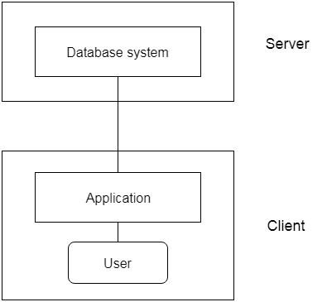
Fig: 2-tier Architecture

3-Tier Architecture
- The 3-Tier architecture contains another layer between the client and server. In this architecture, client can't directly communicate with the server.
- The application on the client-end interacts with an application server which further communicates with the database system.
- End user has no idea about the existence of the database beyond the application server. The database also has no idea about any other user beyond the application.
- The 3-Tier architecture is used in case of large web application.
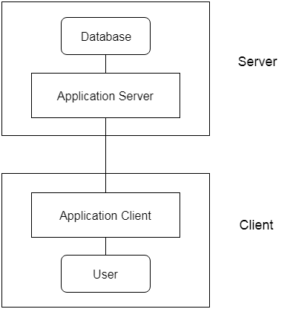
Fig: 3-tier Architecture

Components of DBMS
DBMS stands for DataBase Management System. DBMS is a type of software by which we can save and retrieve the user's data with the security process. DBMS can manipulate the database with the help of a group of programs. The DBMS can accept the request from the operating system to supply the data. The DBMS also can accept the request to retrieve a large amount of data through the user and third-party software.
DBMS also give permission to the user to use the data according to their needs. The word "DBMS" contains information regarding the database program and the users. It also provides an interface between the user and the software. In this topic, we are going to discuss the various types of DBMS.

Components of DBMS
There are many components available in the DBMS. Each component has a significant task in the DBMS. A database environment is a collection of components that regulates the use of data, management, and a group of data. These components consist of people, the technique of Handel the database, data, hardware, software, etc. there are several components available for the DBMS. We are going to explain five main topics of the database below

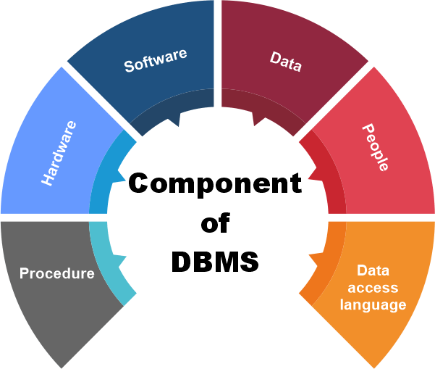

1. Hardware
- Here the hardware means the physical part of the DBMS. Here the hardware includes output devices like a printer, monitor, etc., and storage devices like a hard disk.
- In DBMS, information hardware is the most important visible part. The equipment which is used for the visibility of the data is the printer, computer, scanner, etc. This equipment is used to capture the data and present the output to the user.
- With the help of hardware, the DBMS can access and update the database.
- The server can store a large amount of data, which can be shared with the help of the user's own system.
- The database can be run in any system that ranges from microcomputers to mainframe computers. And this database also provides an interface between the real worlds to the database.
- When we try to run any database software like MySQL, we can type any commands with the help of our keyboards, and RAM, ROM, and processor are part of our computer system.

2. Software
- Software is the main component of the DBMS.
- Software is defined as the collection of programs that are used to instruct the computer about its work. The software consists of a set of procedures, programs, and routines associated with the computer system's operation and performance. Also, we can say that computer software is a set of instructions that is used to instruct the computer hardware for the operation of the computers.
- The software includes so many software like network software and operating software. The database software is used to access the database, and the database application performs the task.
- This software has the ability to understand the database accessing language and then convert these languages to real database commands and then execute the database.
- This is the main component as the total database operation works on a software or application. We can also be called as database software the wrapper of the whole physical database, which provides an easy interface for the user to store, update and delete the data from the database.
- Some examples of DBMS software include MySQL, Oracle, SQL Server, dBase, FileMaker, Clipper, Foxpro, Microsoft Access, etc.

3. Data
- The term data means the collection of any raw fact stored in the database. Here the data are any type of raw material from which meaningful information is generated.
- The database can store any form of data, such as structural data, non-structural data, and logical data.
- The structured data are highly specific in the database and have a structured format. But in the case of non-structural data, it is a collection of different types of data, and these data are stored in their native format.
- We also call the database the structure of the DBMS. With the help of the database, we can create and construct the DBMS. After the creation of the database, we can create, access, and update that database.
- The main reason behind discovering the database is to create and manage the data within the database.
- Data is the most important part of the DBMS. Here the database contains the actual data and metadata. Here metadata means data about data.
- For example, when the user stores the data in a database, some data, such as the size of the data, the name of the data, and some data related to the user, are stored within the database. These data are called metadata.

4. Procedures
- The procedure is a type of general instruction or guidelines for the use of DBMS. This instruction includes how to set up the database, how to install the database, how to log in and log out of the database, how to manage the database, how to take a backup of the database, and how to generate the report of the database.
- In DBMS, with the help of procedure, we can validate the data, control the access and reduce the traffic between the server and the clients. The DBMS can offer better performance to extensive or complex business logic when the user follows all the procedures correctly.
- The main purpose of the procedure is to guide the user during the management and operation of the database.
- The procedure of the databases is so similar to the function of the database. The major difference between the database procedure and database function is that the database function acts the same as the SQL statement. In contrast, the database procedure is invoked using the CALL statement of the DBMS.
- Database procedures can be created in two ways in enterprise architecture. These two ways are as below.
- The individual object or the default object.

Database Access Language
- Database Access Language is a simple language that allows users to write commands to perform the desired operations on the data that is stored in the database.
- Database Access Language is a language used to write commands to access, upsert, and delete data stored in a database.
- Users can write commands or query the database using Database Access Language before submitting them to the database for execution.
- Through utilizing the language, users can create new databases and tables, insert data and delete data.
- Examples of database languages are SQL (structured query language), My Access, Oracle, etc. A database language is comprised of two languages.

1.Data Definition Language (DDL): It is used to construct a database. DDL implements database schema at the physical, logical, and external levels.
The following commands serve as the base for all DDL commands:
- ALTER
- CREATE
- DROP
2. Data Manipulation Language (DML): It is used to access a database. The DML provides the statements to retrieve, modify, insert and delete the data from the database.
The following commands serve as the base for all DML commands:
- INSERT
- UPDATE
- DELETE
- SELECT

6. People
- The people who control and manage the databases and perform different types of operations on the database in the DBMS.
- The people include database administrator, software developer, and End-user.
- Database administrator-database administrator is the one who manages the complete database management system. DBA takes care of the security of the DBMS, its availability, managing the license keys, managing user accounts and access, etc.
- Software developer- the This user group is involved in developing and designing the parts of DBMS. They can handle massive quantities of data, modify and edit databases, design and develop new databases, and troubleshoot database issues.
- End user - These days, all modern web or mobile applications store user data. How do you think they do it? Yes, applications are programmed in such a way that they collect user data and store the data on a DBMS system running on their server. End users are the ones who store, retrieve, update and delete data.
- The users of the database can be classified into different groups.
  - Native Users
  - Online Users
  - Specialized Users
  - Application Users
  - DBA - Database Administrator

TYPES OF DATA MODELS-
In order to define the connections, organization, and structure of data in a database management system (DBMS), data models are essential. The effectiveness of a database’s ability to store, retrieve, and alter data is greatly influenced by the choice of data model. The Hierarchical, Network, and Relational models are some of the oldest types of data models; each has special traits and applications. It is crucial to comprehend how these models vary in order to choose the right one for a given set of circumstances.

What is a Hierarchical Data Model?
The hierarchical data model is the oldest type of the data model. It was developed by IBM in 1950s. It organizes data in a tree-like structure.
In a hierarchical model, data are viewed as a collection of tables, or we can say segments that form a hierarchical relation. In this, the data is organized into a tree-like structure where each record consists of one parent record and many children. Hierarchical model consists of the following:
- It contains nodes which are connected by branches.
- The topmost node is called the root node.
- If there are multiple nodes appear at the top level, then these can be called root segments.
- Each node has exactly one parent.
- One parent may have many children.

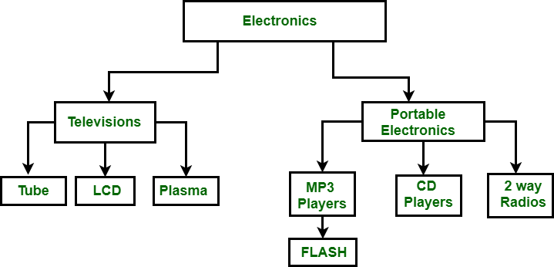
In the above figure, Electronics is the root node which has two children i.e. Televisions and Portable Electronics. These two has further children for which they act as parent. For example: Television has children as Tube, LCD and Plasma, for these three Television act as parent. It follows one to many relationships.

Advantages of the Hierarchical Data Model
- Because of its tree form, it is easy to grasp.
- Retrieving data in a one-to-many connection is efficient.

Disadvantages of the Hierarchical Data Model
- Inflexibility in reorganizing data.
- accessing complicated data structures may be challenging.
- redundant data storage, which might cause anomalies and inconsistencies.

What is a Network Data Model?
It is the advance version of the hierarchical data model. To organize data it uses directed graphs instead of the tree-structure. In this child can have more than one parent. It uses the concept of the two data structures i.e. Records and Sets.
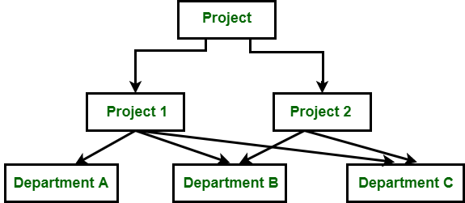

In the above figure, Project is the root node which has two children i.e. Project 1 and Project 2. Project 1 has 3 children and Project 2 has 2 children. Total there are 5 children i.e Department A, Department B and Department C, they are network related children as we said that this model can have more than one parent. So, for the Department B and Department C have two parents i.e. Project 1 and Project 2.

Advantages of the Network Data Model
- Because of its numerous parent ties, it is more adaptable than the hierarchical approach.
- Ideal for managing intricate, many-to-many connections.

Disadvantages of the Network Data Model
- Increased complexity in database design and management.
- requires complex programming in order to manage and work with data.

What is a Relational Data Model?
The relational data model was developed by E.F. Codd in 1970. There are no physical links as they are in the hierarchical data model. Following are the properties of the relational data model:
- Data is represented in the form of table only.
- It deals only with the data not with the physical structure.
- It provides information regarding metadata.
- At the intersection of row and column there will be only one value for the tuple.
- It provides a way to handle the queries with ease.
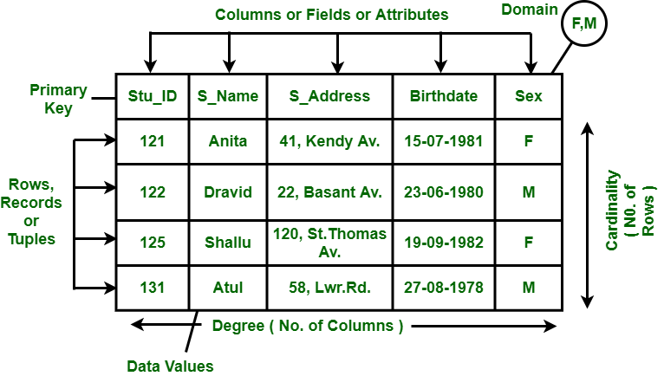

Advantages of the Relational Data Model
- High data independence and flexibility.
- offers robust and user-friendly querying features.
- removes duplication by use of normalization.

Disadvantages of the Relational Data Model
- For certain kinds of straightforward data retrieval tasks, they may not perform as well as hierarchical models.
- demands a deeper comprehension of SQL and normalization principles.

Difference Between Hierarchical, Network and Relational Data Model

Hierarchical Data Model | Network Data Model | Relational Data Model
In this model, to store data hierarchy method is used. It is the oldest method and not in use today. | It organizes records to one another through links or pointers. | It organizes records in the form of table and relationship between tables are set using common fields.
To organize records, it uses tree structure. | It organizes records in the form of directed graphs. | It organizes records in the form of tables.
It implements 1:1 and 1:n relations. | In addition to 1:1 and 1:n it also implements many to many relationships. | In addition to 1:1 and 1:n it also implements many to many relationships.
Pointers are used to establish relationships among records physically. | A linked list is used to establish a relationship among records physically. | The logical representation is used with rows and columns to depict relationship among records.
Insertion anomaly exits in this model i.e. child node cannot be inserted without the parent node. | There is no insertion anomaly. | There is no insertion anomaly.
Deletion anomaly exists in this model i.e. it is difficult to delete the parent node. | There is no deletion anomaly. | There is no deletion anomaly.
Update leads to inconsistency problems because of the existence of multiple instances of a child record. | No such problem as only one instance of records exist. | Updating a record is easy and simple with the process of normalization, the redundant data gets removed.
This model lacks data independence. | There is partial data independence in this model. | This model provides data independence.
No such facility for querying database is supported. | No such facility for querying database is supported. | SQL-based declarative querying is supported.
It is used to access the data which is complex and asymmetric. | It is used to access the data which is complex and symmetric. | It is used to access the data which is complex and symmetric.
Difficult to design a database because of its complexity. | Difficult to design a database and manipulate a database because of its complexity. Hence, it imposes a burden on the programmer. | It is easy to comprehend due to concealed physical level details from end-users.
It is less flexible. | It is flexible as compared to the hierarchical model. | It is flexible as compared to the hierarchical model.

The primary types of data models in DBMS are: Hierarchical, Network, Relational, and Object-Oriented; where hierarchical organizes data in a tree-like structure, network allows for more complex relationships between entities, relational structures data in tables with rows and columns, and object-oriented models data as real-world objects with attributes and methods.
Explanation of each model:
- Hierarchical Model:
Data is organized in a parent-child hierarchy, where each entity can only have one parent, creating a tree-like structure.
- Network Model:
More flexible than hierarchical, allowing an entity to have multiple parent entities, creating a complex web of relationships.
- Relational Model:
The most widely used model, where data is organized into tables with rows and columns, with relationships defined through common fields (foreign keys) between tables.
- Object-Oriented Model:
Represents data as real-world objects with attributes and methods, aiming to capture complex relationships and behaviours directly.
Approaches to building a database

In summary, file systems are suitable for managing small amounts of unstructured data , while DBMS is designed for managing large amounts of structured data, and offers more advanced features for ensuring data integrity, security, and performance.

The term 'file-based approach' refers to the situation where data is stored in one or more separate computer files defined and managed by different application programs.

An information system that uses a Database Management System (DBMS) to manage its information has a particular structure, comprising three components: Data, DBMS, and Application software. This structure, as described below, is referred to as the database approach to information system development.

What is file approach and database approach?
In this approach, data is managed through file operations like reading, writing, and deleting files. On the other hand, a database approach involves using a centralized and structured system for data management. Databases are designed to store and organize data in a highly efficient and interconnected manner.

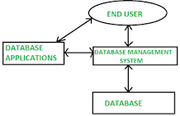

File System Approach
File based systems were an early attempt to computerize the manual system. It is also called a traditional based approach in which a decentralized approach was taken where each department stored and controlled its own data with the help of a data processing specialist. The main role of a data processing specialist was to create the necessary computer file structures, and also manage the data within structures and design some application programs that create reports based on file data.
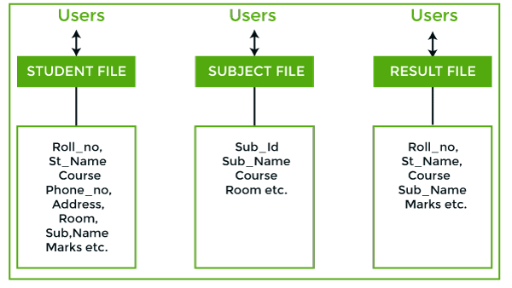
In the above figure:
Consider an example of a student's file system. The student file will contain information regarding the student (i.e. roll no, student name, course etc.). Similarly, we have a subject file that contains information about the subject and the result file which contains the information regarding the result.
Some fields are duplicated in more than one file, which leads to data redundancy. So to overcome this problem, we need to create a centralized system, i.e. DBMS approach.

DBMS:
A database approach is a well-organized collection of data that are related in a meaningful way which can be accessed by different users but stored only once in a system. The various operations performed by the DBMS system are: Insertion, deletion, selection, sorting etc.
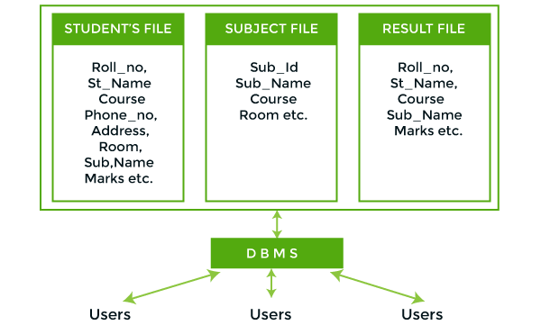
In the above figure,
In the above figure, duplication of data is reduced due to centralization of data.
There are the following differences between DBMS and File systems:
KKUGT | DBMS Approach | File System Approach
Meaning | DBMS is a collection of data. In DBMS, the user is not required to write the procedures. | The file system is a collection of data. In this system, the user has to write the procedures for managing the database.
Sharing of data | Due to the centralized approach, data sharing is easy. | Data is distributed in many files, and it may be of different formats, so it isn't easy to share data.
Data Abstraction | DBMS gives an abstract view of data that hides the details. | The file system provides the detail of the data representation and storage of data.
Security and Protection | DBMS provides a good protection mechanism. | It isn't easy to protect a file under the file system.
Recovery Mechanism | DBMS provides a crash recovery mechanism, i.e., DBMS protects the user from system failure. | The file system doesn't have a crash mechanism, i.e., if the system crashes while entering some data, then the content of the file will be lost.
Manipulation Techniques | DBMS contains a wide variety of sophisticated techniques to store and retrieve the data. | The file system can't efficiently store and retrieve the data.
Concurrency Problems | DBMS takes care of Concurrent access of data using some form of locking. | In the File system, concurrent access has many problems like redirecting the file while deleting some information or updating some information.
Where to use | Database approach used in large systems which interrelate many files. | File system approach used in large systems which interrelate many files.
Cost | The database system is expensive to design. | The file system approach is cheaper to design.
Data Redundancy and Inconsistency | Due to the centralization of the database, the problems of data redundancy and inconsistency are controlled. | In this, the files and application programs are created by different programmers so that there exists a lot of duplication of data which may lead to inconsistency.
Structure | The database structure is complex to design. | The file system approach has a simple structure.
Data Independence | In this system, Data Independence exists, and it can be of two types.  - Logical Data Independence  - Physical Data Independence | In the File system approach, there exists no Data Independence.
Integrity Constraints | Integrity Constraints are easy to apply. | Integrity Constraints are difficult to implement in file system.
Data Models | In the database approach, 3 types of data models exist:  - Hierarchal data models  - Network data models  - Relational data models | In the file system approach, there is no concept of data models exists.
Flexibility | Changes are often a necessity to the content of the data stored in any system, and these changes are more easily with a database approach. | The flexibility of the system is less as compared to the DBMS approach.
Examples | Oracle, SQL Server, Sybase etc. | Cobol, C++ etc.

Characteristics of Database approach in DBMS
A database control machine (DBMS) is a software program gadget that permits the creation, organization, management, and retrieval of records in a dependent manner. The database method is a way of organizing information in a DBMS that has distinct characteristics that make it distinctive from different techniques. In this newsletter, we will speak about the characteristics of the database technique in DBMS.
- Data Independence: - One of the important characteristics of the database approach is information independence. The database method allows for the separation of the bodily garage of information from the logical business enterprise of information. This manner of adjustments made to the bodily storage of facts do no longer affect the logical organization of the records, and vice versa. As a result, applications that use the database can be modified without affecting the underlying information.
- Data Integration: - Another characteristic of the database approach is statistics integration. The database technique allows for the integration of statistics from distinct sources right into a single database. This means that information may be shared between extraordinary packages, reducing redundancy and improving facts consistency.
- Centralized Control: - The database method allows for centralized manipulation of information. This approach means that statistics may be controlled and controlled from a single location, making it less difficult to put in force information safety and get entry to control guidelines.
- Consistency: - The database technique presents consistency in records storage and retrieval. Data within the database is organized in a constant and predictable manner, making it less difficult to retrieve and examine facts. Consistency is maintained through using guidelines and constraints that make certain that records are entered and saved in the ideal format.
- Scalability: - The database technique is scalable, allowing for the control of massive amounts of statistics. The use of a DBMS allows for the control of facts in a dependent way, making it less difficult to manage and retrieve big amounts of records.
- Security: - The database technique gives information security. Data can be secured via the use of get entry to control policies and encryption. This guarantees that statistics is only accessed by means of authorized users and that touchy statistics is included from unauthorized access.
- Concurrent Access: - The database technique lets in for concurrent access to records. Multiple users can get entry to the equal facts simultaneously, ensuring that records are available to all customers in real-time. This is finished via using locking mechanisms that save you multiple customers from modifying the identical facts concurrently.
- Data Modelling: - The database approach lets in for the usage of data modelling techniques to create a logical representation of information. Data modelling is a system that includes figuring out the facts, entities, attributes, and relationships in a device. By the usage of facts modelling strategies, builders can create a clear expertise of the statistics in a device and the way its miles related, making it less complicated to layout the database schema.
- Data Integrity: - The database technique offers mechanisms for making sure statistics integrity. This includes the use of facts constraints which includes primary keys, foreign keys, and take a look at constraints, which ensure that statistics is entered in the correct format and that relationships between records are maintained.
- Data Querying: - The database method affords effective records querying capabilities. The use of Structured Query Language (SQL) lets in customers to retrieve and manipulate facts in a flexible and efficient manner. SQL allows for the filtering, sorting, grouping, and aggregation of records, making it simpler to extract insights from large amounts of information.
- Data Backup and Recovery: - The database approach presents mechanisms for statistics backup and recuperation. This approach means that in the event of facts loss or corruption, statistics can be restored to a preceding country. DBMSs offer mechanisms for growing backups of the database at regular durations and for restoring data from these backups within the event of records loss.
- Data Replication: - The database technique lets in for the replication of information across a couple of servers. Data replication is the method of copying records from one server to any other, providing redundancy and improving data availability. By replicating information throughout multiple servers, groups can ensure that information is available in the occasion of a server failure.
In the end, the database method is an effective approach for organizing and managing records in a DBMS. The characteristics of the database technique encompass facts independence, statistics integration, centralized control, consistency, scalability, safety, concurrent access, records modeling, statistics integrity, information querying, information backup and restoration, facts replication, facts evaluation, and application improvement. By the use of the database approach, agencies can improve information control and accessibility, making it less complicated to extract insights from large quantities of facts.

Challenges in building a DBMS

